SEMMDD CrashCourse

SEMMDD as a project is currently focused on bringing depression oriented data to the semantic web and applying reasoning on this data via various modeling. The members of SEMMDD vary in their focus, expertise, and location. The data is also wide spread both in location and in accessibility. All of this variance present in the SEMMDD ecosystem can easily cause headache and confusion. In an effort to make contributing to the SEMMDD project approachable this guide was created.

Let us start by overviewing the current structure of SEMMDD. Where *is* everything hiding?

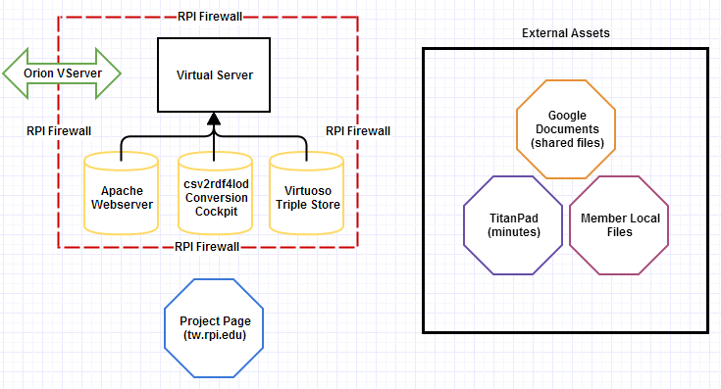

Figure : SEMMDD Project Structure

There are two main groupings of materials relating to SEMMDD: a virtual server and external assets. The virtual server resides on RPI hardware and is maintained directly by the members of SEMMDD thus it is considered “internal” to the project as the project is based within Tetherless World which is a department within RPI. The other assets are considered external since they reside on systems outside of RPI and not maintained by Tetherless World. These include services such as a member’s own computer, Tetherless World’s Titanpad account (twc.titanpad.com), or files stored on Google Documents (Now called Google Drive).

SEMMDD deals with medical data and thus it is important to keep certain aspects of the project private. Privacy is accomplished through the RPI firewall, and password protected systems. A quick breakdown of what is public versus what is private is as follows:

Public facing assets:

* TitanPad: meeting minutes and various notes.
  + Accessed via: <http://twc.titanpad.com/505>
  + Edited via: publicly editable
* Project Page: project documents, an overview of SEMMDD, and a member list.
  + Accessed via: <http://tw.rpi.edu/web/project/SEMMDD>
  + Edited via: have an account on tw.rpi.edu
* Google Documents: numerous SEMMDD files, minutes, and documents